Question 1: Create HTML file with JS element:
- Write YOUR NAME and ID as a comment at the top of the HTML file.
- Ask the user the following questions:
What is your favorite number?
    - If the entered number is even;
print “The entered number is even”,
    - Otherwise; print “The entered number is odd”.
The program Output
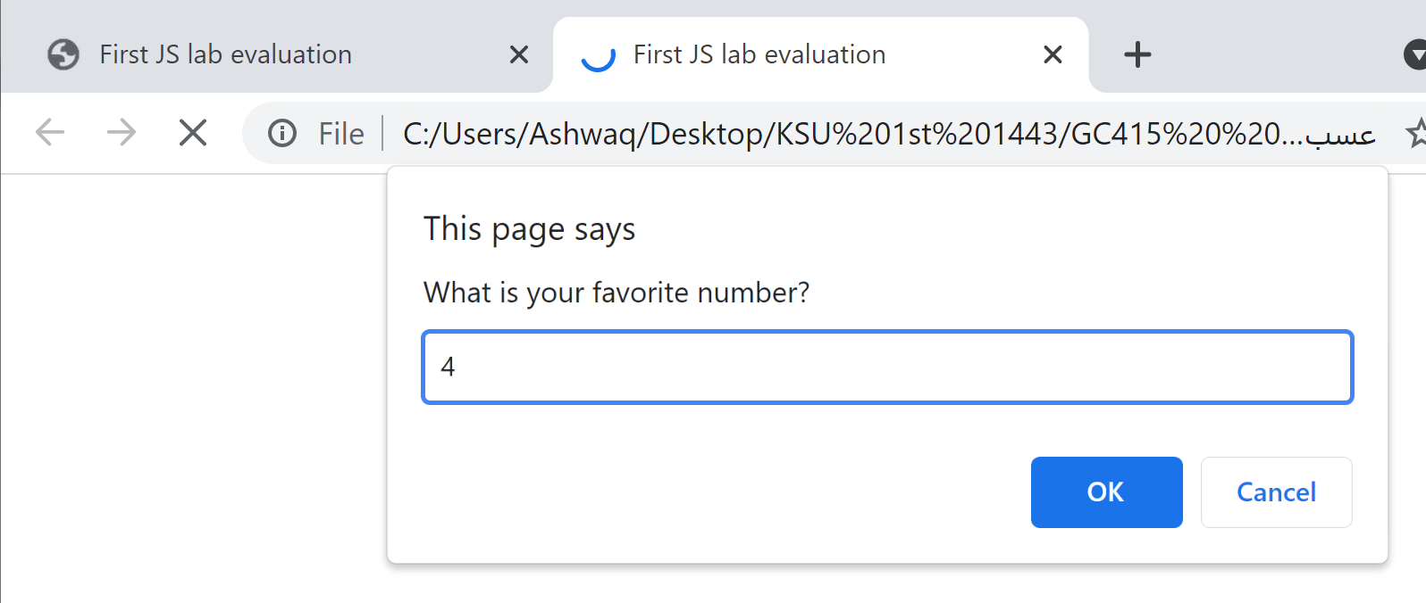
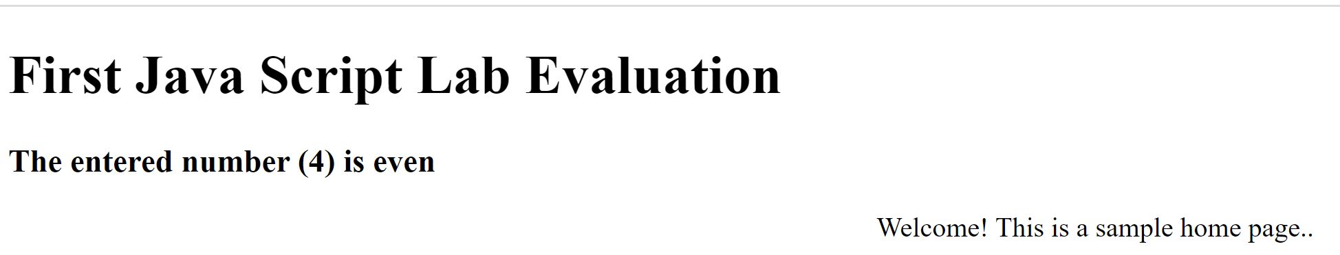
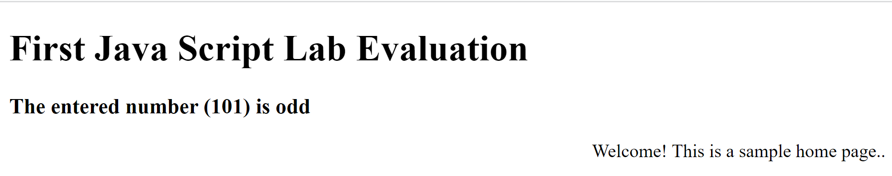
شوق حامد سعيد العتيبي
441925278
